**Instructor:** Yerasyl Amanbek

**Student:** Amir Yakubov

**Date:** 25.05.2021

**Part 1. Connection to Thingspeak.** **(50%)**  
*Implement project:* [*https://www.mathworks.com/help/thingspeak/google-ifttt-thingspeak-lamp.html*](https://www.mathworks.com/help/thingspeak/google-ifttt-thingspeak-lamp.html)

1. in IFTTT Replace google assistant with **timer**.

**2.** Trigger light on 3 times and light off 3 times. Show the results (Provide screenshot).

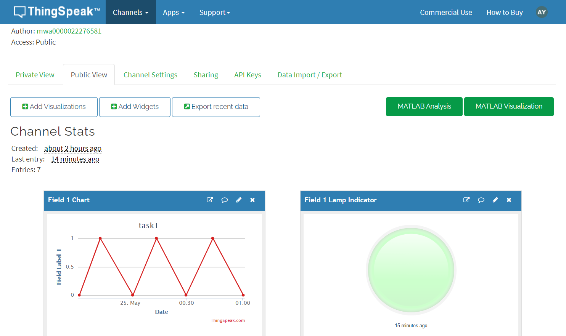

**3.** Provide link to public thingspeak channel.

<https://thingspeak.com/channels/1398447>   
  
  
**Part 2. About me Android app (50%)**

*Build about me app following:* [*https://developer.android.com/codelabs/kotlin-android-training-linear-layout?index=..%2F..android-kotlin-fundamentals#0*](https://developer.android.com/codelabs/kotlin-android-training-linear-layout?index=..%2F..android-kotlin-fundamentals#0)

1. Replace name with your name + id.
2. Change text and write about yourself.
3. Provide screenshot of app.

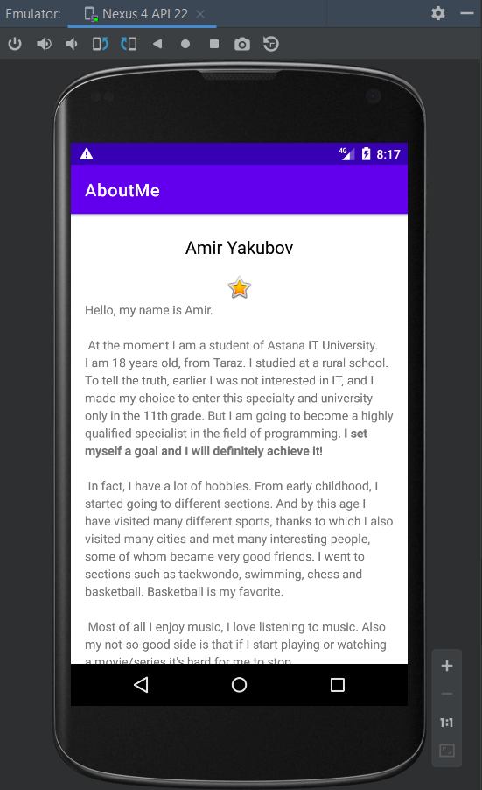

1. Submit project to github and share the link.

<https://github.com/VM1R3/AboutMe.git>